Lab Assignment-04

ROLL: 2005535 | NAME: SAHIL SINGH | DATE: 09/02/22

QUES : Insert the values in the EMP table and run the following queries.

1. Display unique jobs from employee table.  
   2. List the details of the employees in ascending order of their salaries.  
   3. List the details of the employees in ascending order of the department and desc order of their jobs  
   4. List the emps who joined before 1981.  
   5. List the Empno, Ename, Sal, Daily Sal of all Employees in the ASC order of AnnSal.  
   6. List the empno, ename, sal, exp of all emps working for Mgr 7839  
   7. Display the details of the emps whose Comm. Is more than their sal.  
   8. List the emps in the asc order of Designation  
   9. List the emps along with their exp and daily sal is more than Rs.100  
   10. List the emps who are either ‘CLERK’ or ‘ANALYST’ in the desc order  
   11. List the emps who are working for the deptno 10 or 20  
   12. List the emps who are joined in the year 1981  
   13. List the emps who are joined in the month of AUG 1980  
   14. List the emps whose annul sal ranging from 22000 and 45000  
   15. List the emps those are having five characters in their names  
   16. List the enames those are starting with ‘s’ and with fire character  
   17. List the emps those are having four chars and third char must be ‘r'  
   18. List the 5 character names starting with ‘s’ and ending w  
   19. List the emps who joined in January  
   20. List the emps who joined in the month of which second character is ‘a  
   21. List the Employees who joined in January  
   22. List the emps who joined in the month of Aug  
   23. List the emps who joined in 80's  
   24. List the Emps who does not belong to deptno 20  
   25. Find the avg salary of the emps  working under manager

SOLUTION:

Data Insertion:

(EMP TABLE)

SQL> insert into emp values(7839, 'KING', 'PRESIDENT', null, to_date('17-11-1981','dd-mm-yyyy'), 5000, null, 10);

SQL> insert into emp values(7698, 'BLAKE', 'MANAGER', 7839, to_date('1-5-1981','dd-mm-yyyy'), 2850, null, 30);

SQL> insert into emp values(7782, 'CLARK', 'MANAGER', 7839, to_date('9-6-1981','dd-mm-yyyy'), 2450, null, 10);

SQL> insert into emp values(7566, 'JONES', 'MANAGER', 7839, to_date('2-4-1981','dd-mm-yyyy'), 2975, null, 20);

SQL> insert into emp values(7788, 'SCOTT', 'ANALYST', 7566, to_date('13-JUL-87','dd-mm-rr') - 85, 3000, null, 20);

SQL> insert into emp values(7902, 'FORD', 'ANALYST', 7566, to_date('3-12-1981','dd-mm-yyyy'), 3000, null, 20);

SQL> insert into emp values(7369, 'SMITH', 'CLERK', 7902, to_date('17-12-1980','dd-mm-yyyy'), 800, null, 20);

SQL> insert into emp values(7499, 'ALLEN', 'SALESMAN', 7698, to_date('20-2-1981','dd-mm-yyyy'), 1600, 300, 30);

SQL> insert into emp values(7521, 'WARD', 'SALESMAN', 7698, to_date('22-2-1981','dd-mm-yyyy'), 1250, 500, 30);

SQL> insert into emp values(7654, 'MARTIN', 'SALESMAN', 7698, to_date('28-9-1981','dd-mm-yyyy'), 1250, 1400, 30);

SQL> insert into emp values(7844, 'TURNER', 'SALESMAN', 7698, to_date('8-9-1981','dd-mm-yyyy'), 1500, 0, 30);

SQL> insert into emp values(7876, 'ADAMS', 'CLERK', 7788, to_date('13-JUL-87', 'dd-mm-rr') - 51, 1100, null, 20);

SQL> insert into emp values(7900, 'JAMES', 'CLERK', 7698, to_date('3-12-1981','dd-mm-yyyy'), 950, null, 30);

SQL> insert into emp values(7934, 'MILLER', 'CLERK', 7782, to_date('23-1-1982','dd-mm-yyyy'), 1300, null, 10);

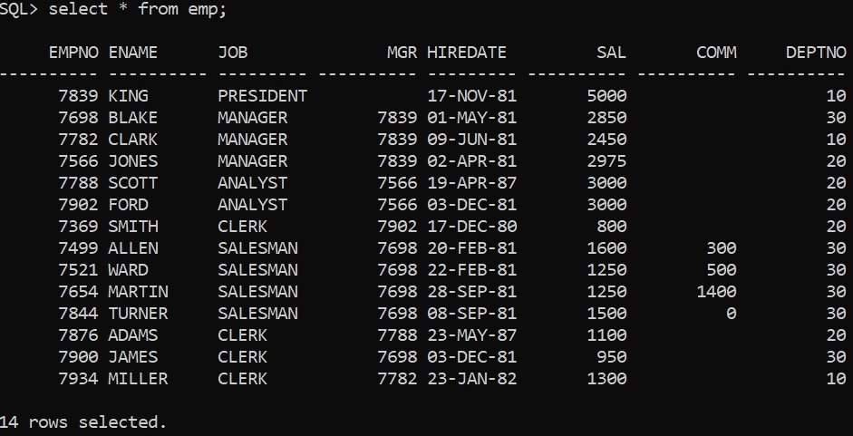

Display unique jobs from employee table.

SQL> select distinct JOB from emp;

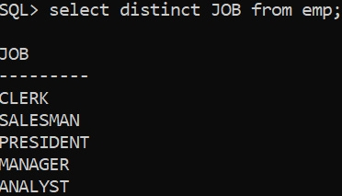

List the details of the employees in ascending order of their salaries.

SQL> select * from emp order by SAL;

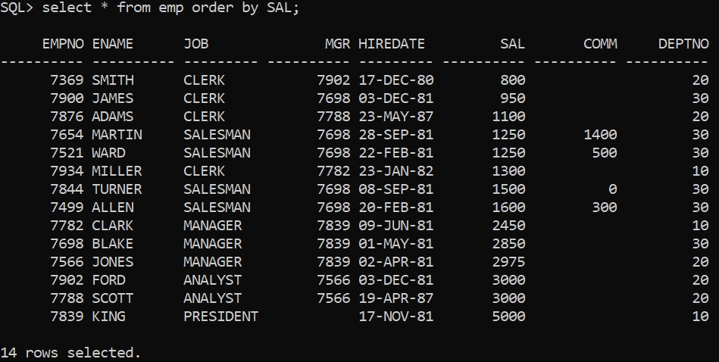

List the details of the employees in ascending order of the department and desc order of their jobs.

SQL> select * from emp order by DEPTNO;

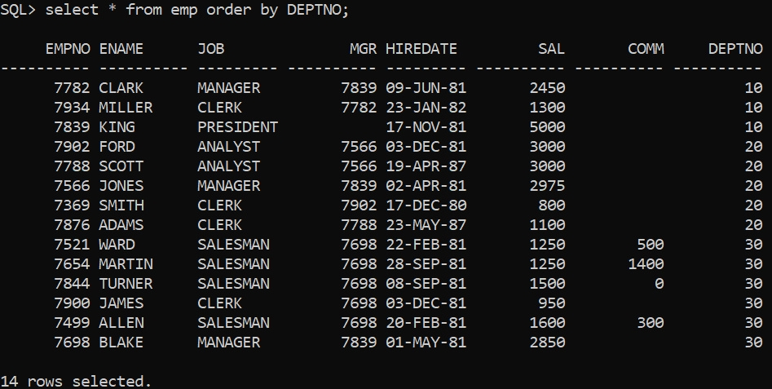

SQL> select * from emp order by JOB DESC;

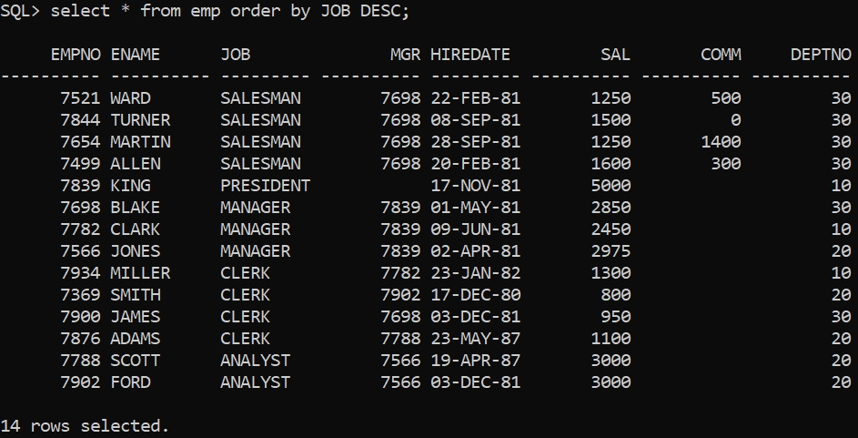

List the emps who joined before 1981.

SQL> select * from emp where extract(year from HIREDATE) < 1981;

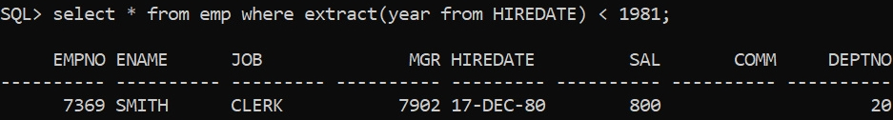

List the Empno, Ename, Sal, Daily Sal of all Employees in the ASC order of AnnSal.

SQL> select EMPNO, ENAME, SAL, (SAL/30) as DAILY_SAL, (SAL*12) as ANNSAL from emp order by (SAL*12);

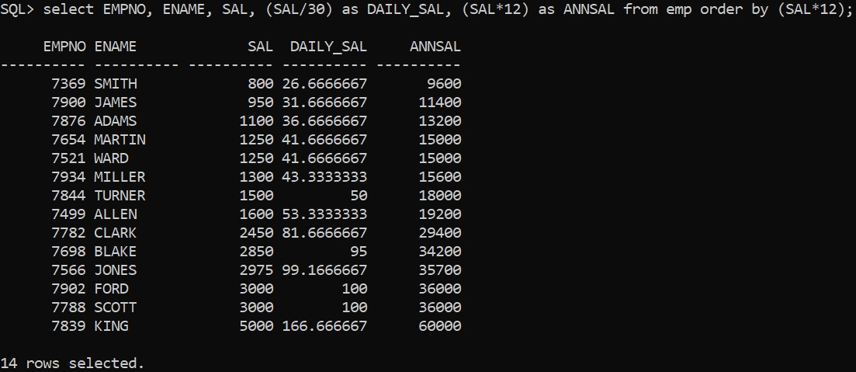

List the empno, ename, sal, exp of all emps working for Mgr 7839.

SQL> select * from EMP where MGR=7839;

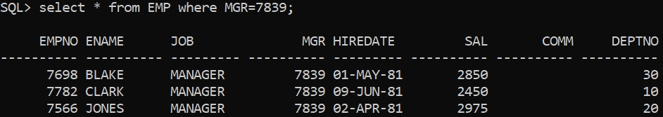

Display the details of the emps whose Comm. Is more than their sal.

SQL> select * from EMP where COMM > SAL;

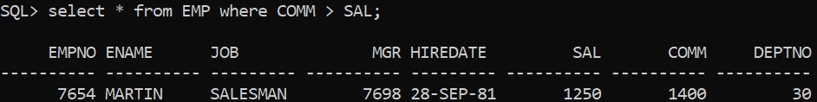

List the emps in the asc order of Designation.

SQL> select * from emp order by JOB;

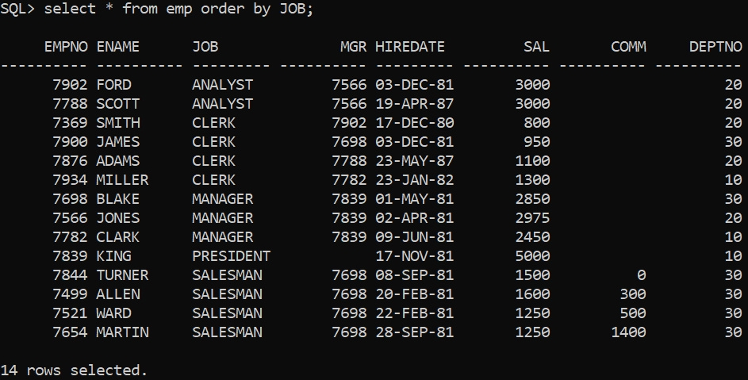

List the emps along with their exp and daily sal is more than Rs.100

SQL> select EMPNO, ENAME, JOB, MGR, HIREDATE, SAL, COMM, DEPTNO, (SAL/30) as DAILY_SAL from emp where (SAL/30) > 100;

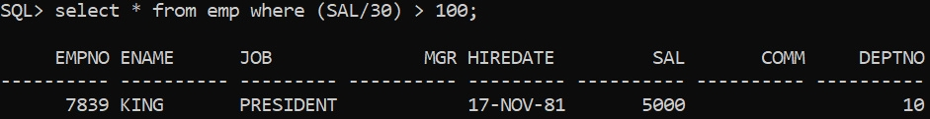

List the emps who are either ‘CLERK’ or ‘ANALYST’ in the desc order.

SQL> select * from EMP where JOB in('CLERK','ANALYST') order by JOB desc;

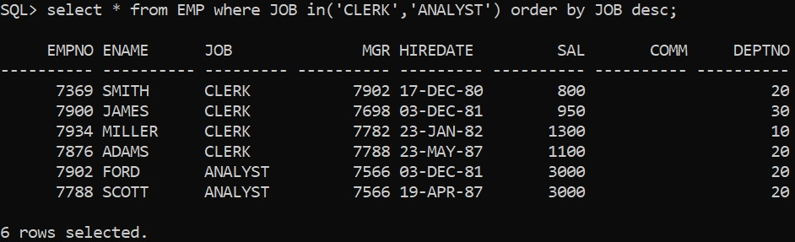

List the emps who are working for the deptno 10 or 20.

SQL> select * from EMP where DEPTNO in(10,20);

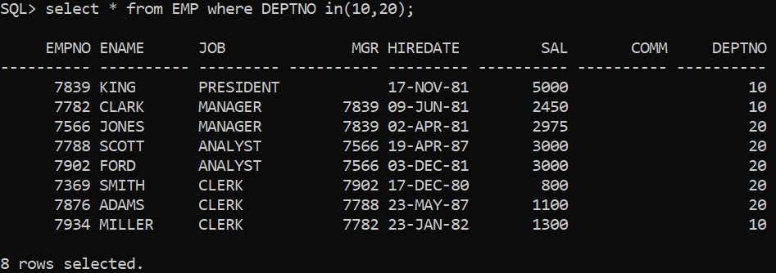

List the emps who are joined in the year 1981.

SQL> select * from emp where extract(year from hiredate) = 1981;

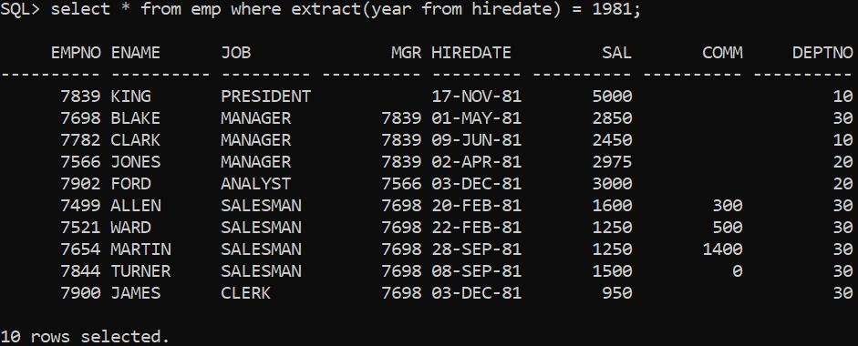

List the emps who are joined in the month of AUG 1980.

SQL> select * from emp where (extract(year from hiredate) = 1980) and (extract(month from hiredate) = 8);



List the emps whose annul sal ranging from 22000 and 45000.

SQL> select EMPNO,ENAME,JOB,MGR,HIREDATE,SAL,(SAL*12) as ANNSAL,COMM,DEPTNO from emp where (SAL*12) between 22000 and 45000;

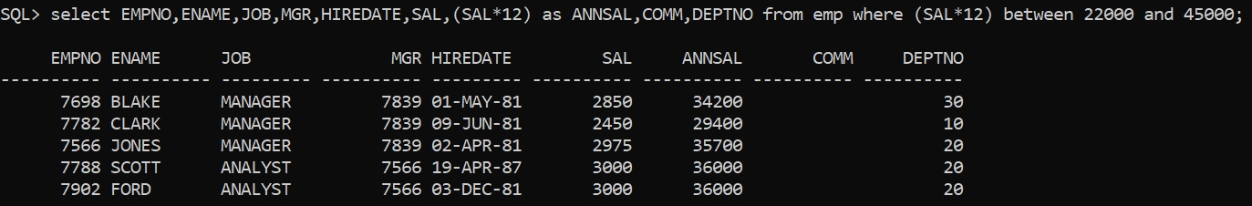

List the emps those are having five characters in their names.

SQL> select * from emp where length(ENAME)=5;

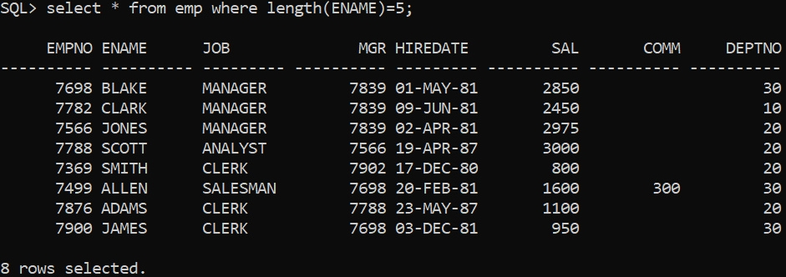

List the enames those are starting with ‘s’ and with fire character.

SQL> select * from emp where ENAME like 'S%';

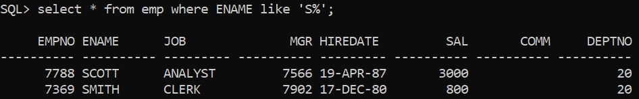

List the emps those are having four chars and third char must be ‘r'.

SQL> select * from emp where length(ENAME) = 4 and (ENAME like '___r%');



List the 5 character names starting with ‘s’ and ending ‘w’.

SQL> select * from emp where length(ENAME) = 5 and (ENAME like 'S%' and ENAME like '%w');



List the emps who joined in January.

SQL> select * from emp where extract(month from hiredate) = 1;

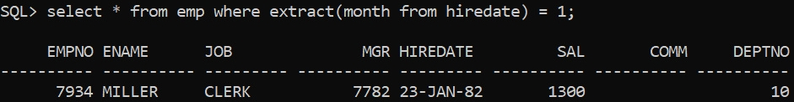

List the emps who joined in the month of which second character is ‘a’.

SQL> select * from emp where to_char(hiredate, 'MONTH') like '_A%';

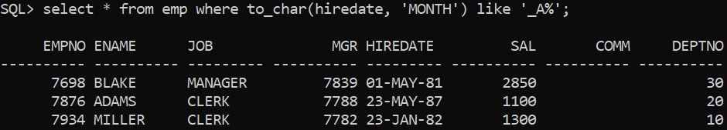

List the Employees who joined in January.

SQL> select * from emp where extract(month from hiredate) = 1;

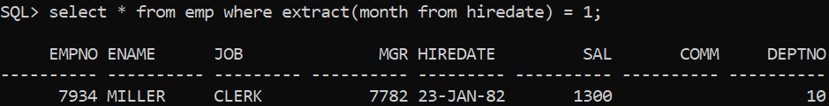

List the emps who joined in the month of Aug.

SQL> select * from emp where extract(month from hiredate) = 8;



List the emps who joined in 80's.

SQL> select * from emp where extract(year from hiredate) between 1980 and 1989;

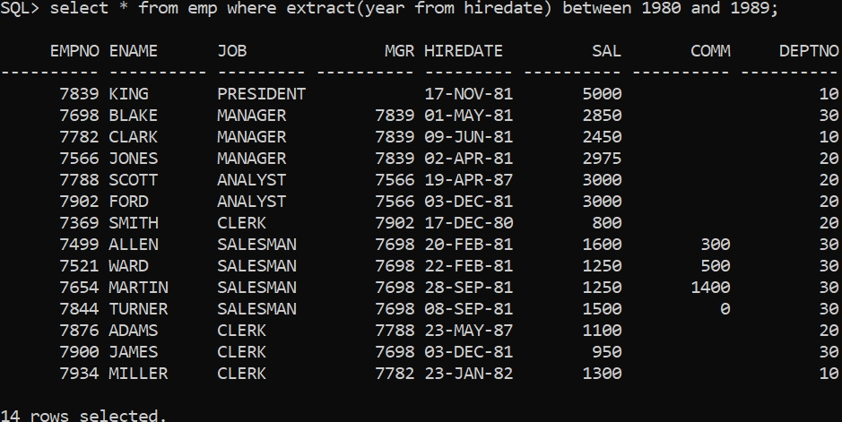

List the Emps who does not belong to deptno 20.

SQL> select * from emp where DEPTNO != 20;

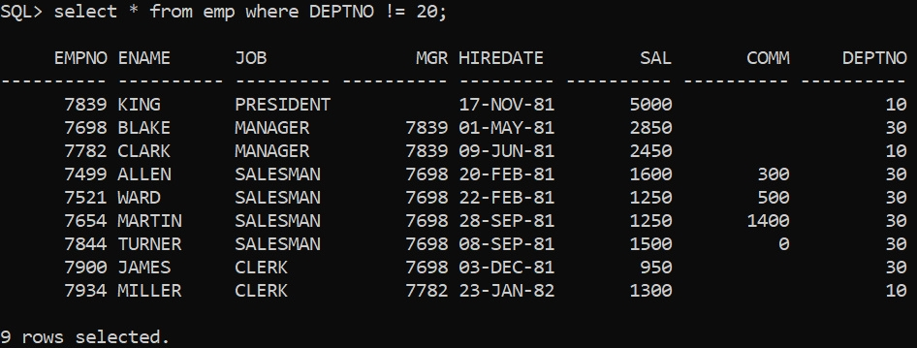

Find the avg salary of the emps  working under manager.

SQL> select AVG(SAL) as AVG_SAL from emp where JOB!='PRESIDENT';



